Task 1 :
VPC : created VPC (VPC id : vpc-0f7c9befbc2c744d3)with the appropriate CIDR block

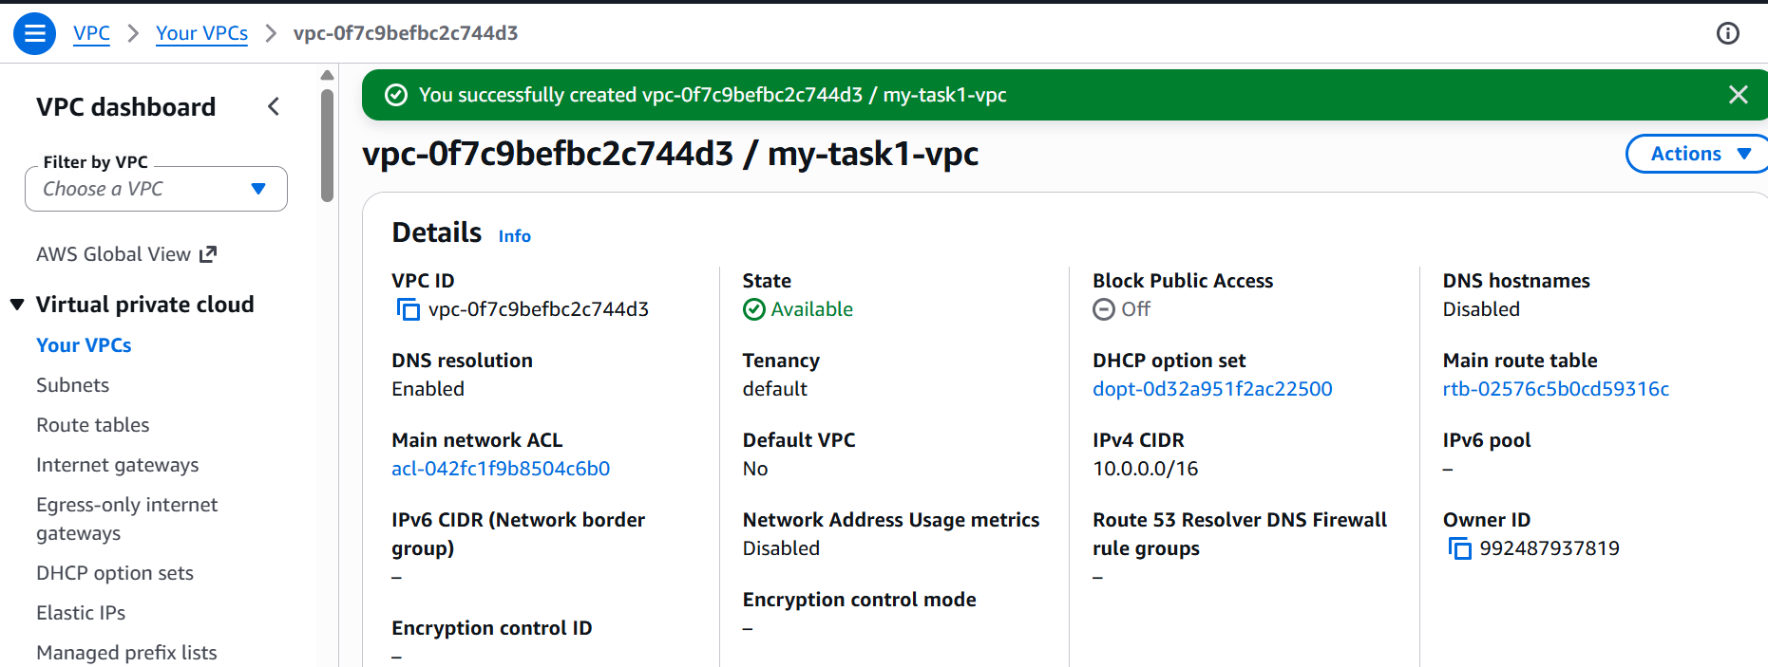

Internet Gateway: Internet Gateway is created and attached it a VPC(vpc-0f7c9befbc2c744d3)

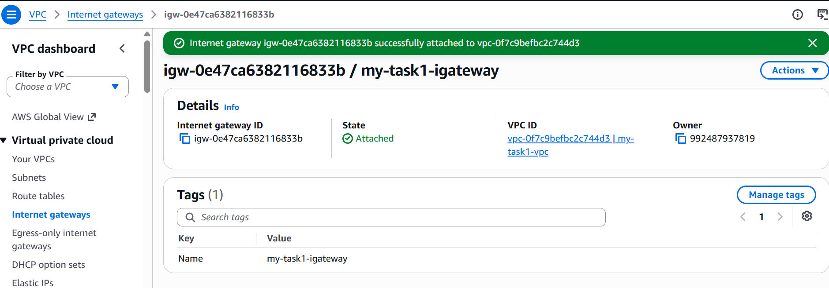

Subnets : created 6 subnets and distributed across two available zones(ap-south-1a and ap-south-1b)
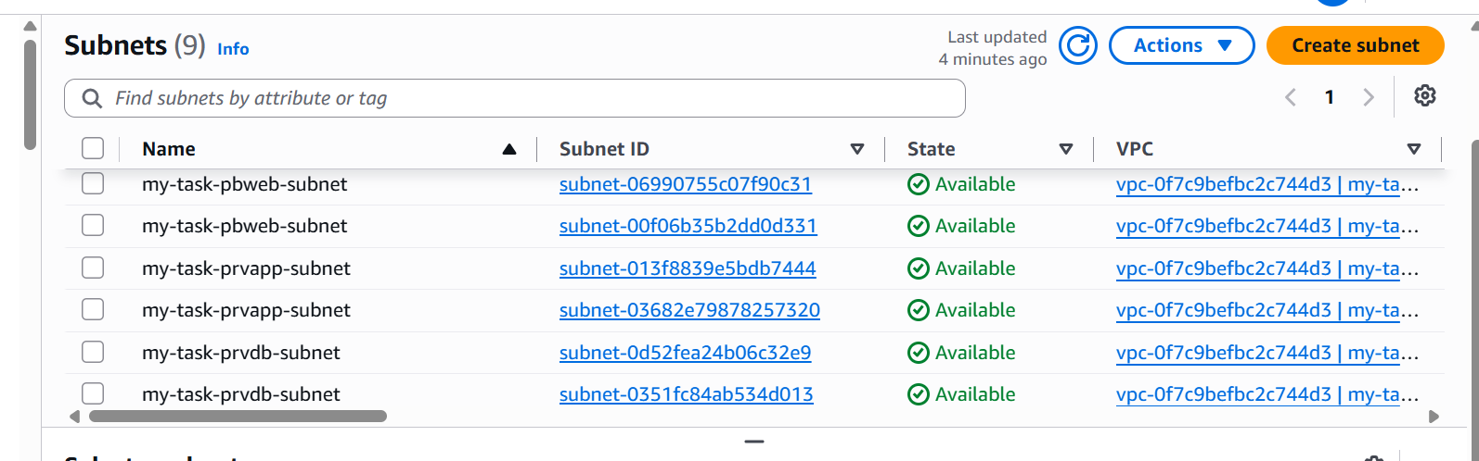

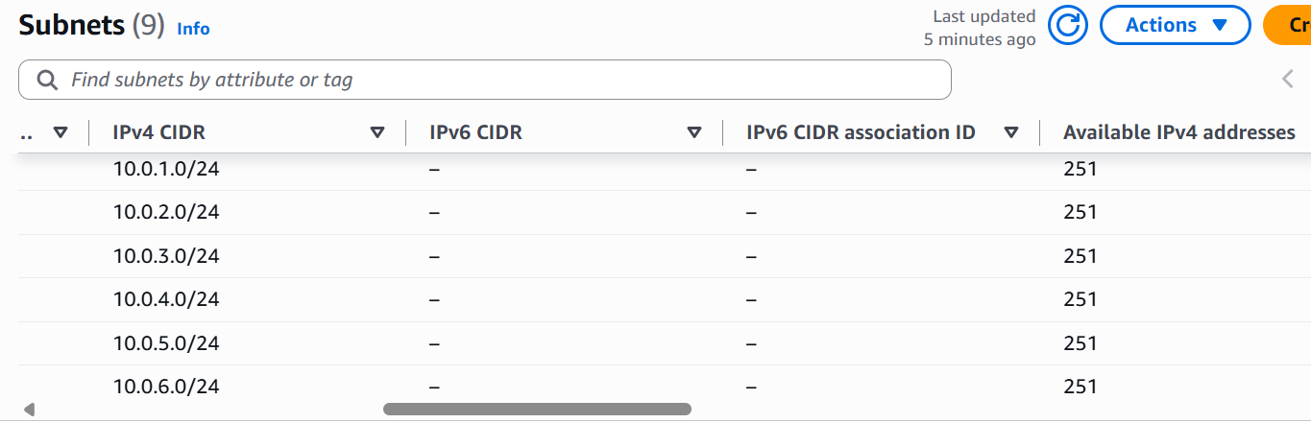
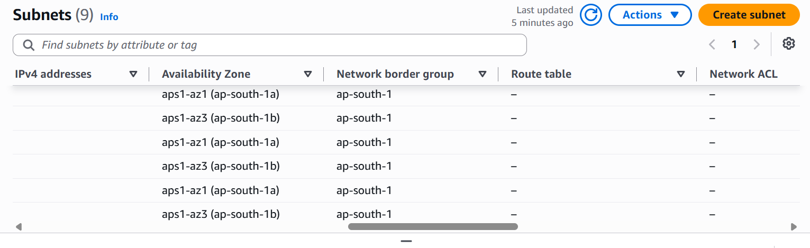
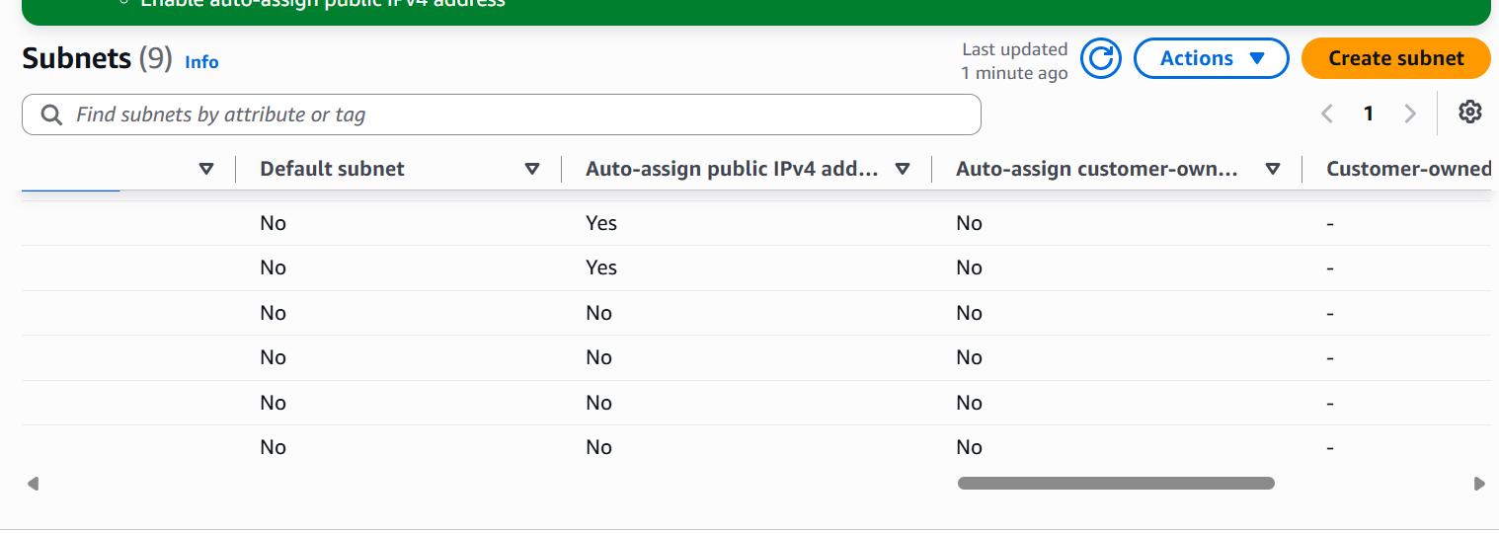

Route table: created 3 route table and associated it with the subnets as mentioned in the task
Public route table associated with public subnet
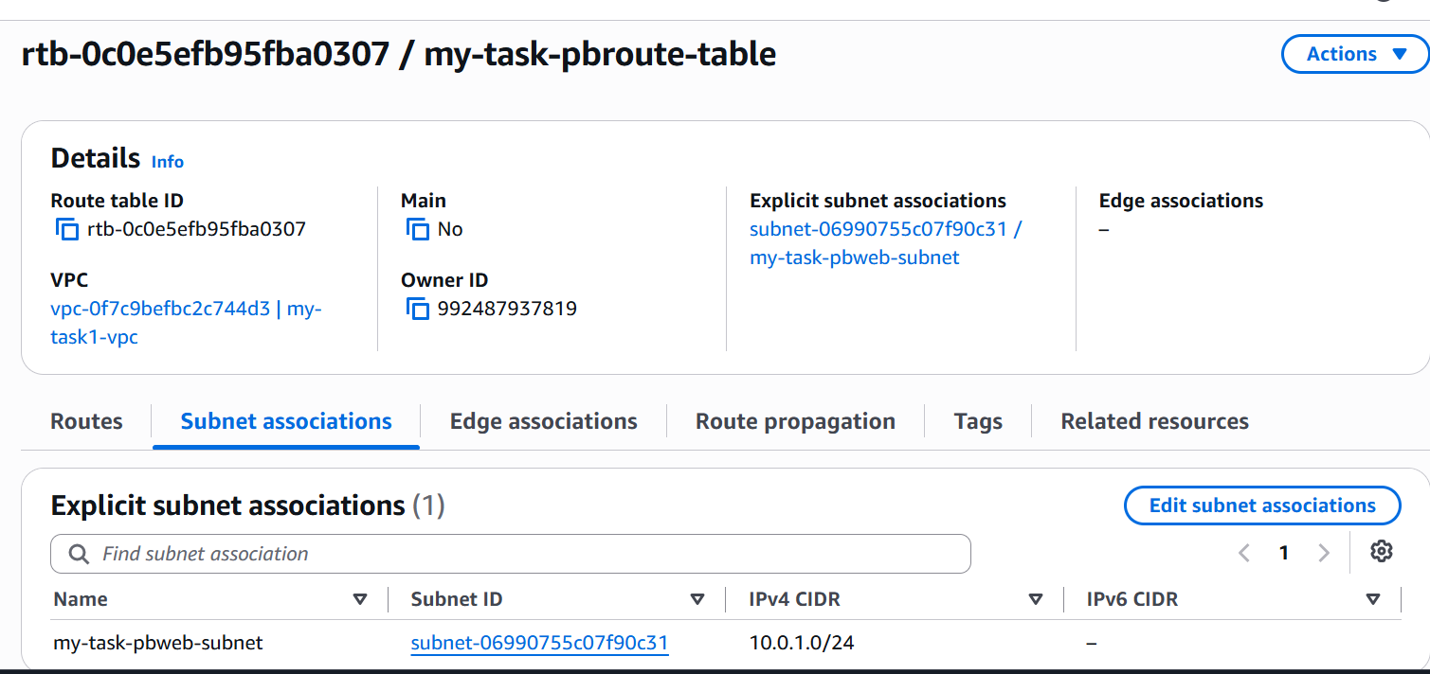

Private application route table associated with private application subnet
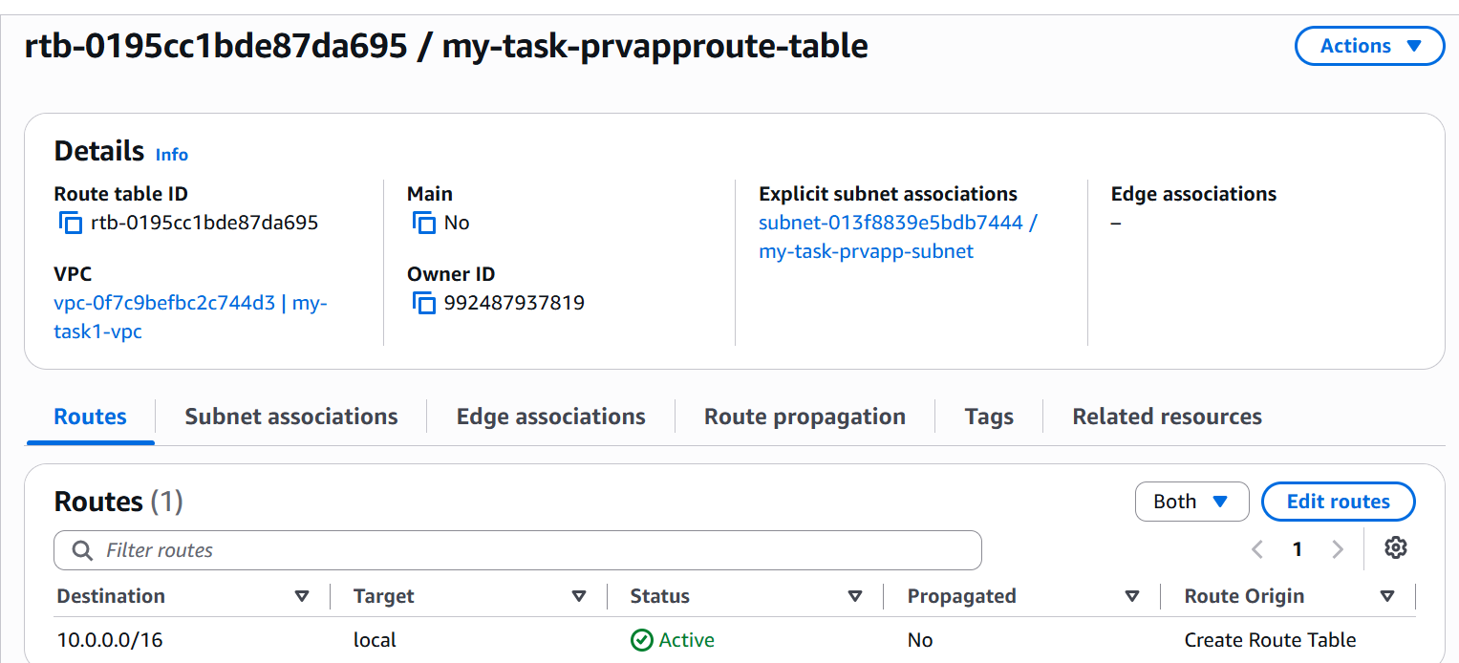

Private database route table associated with private database subnet
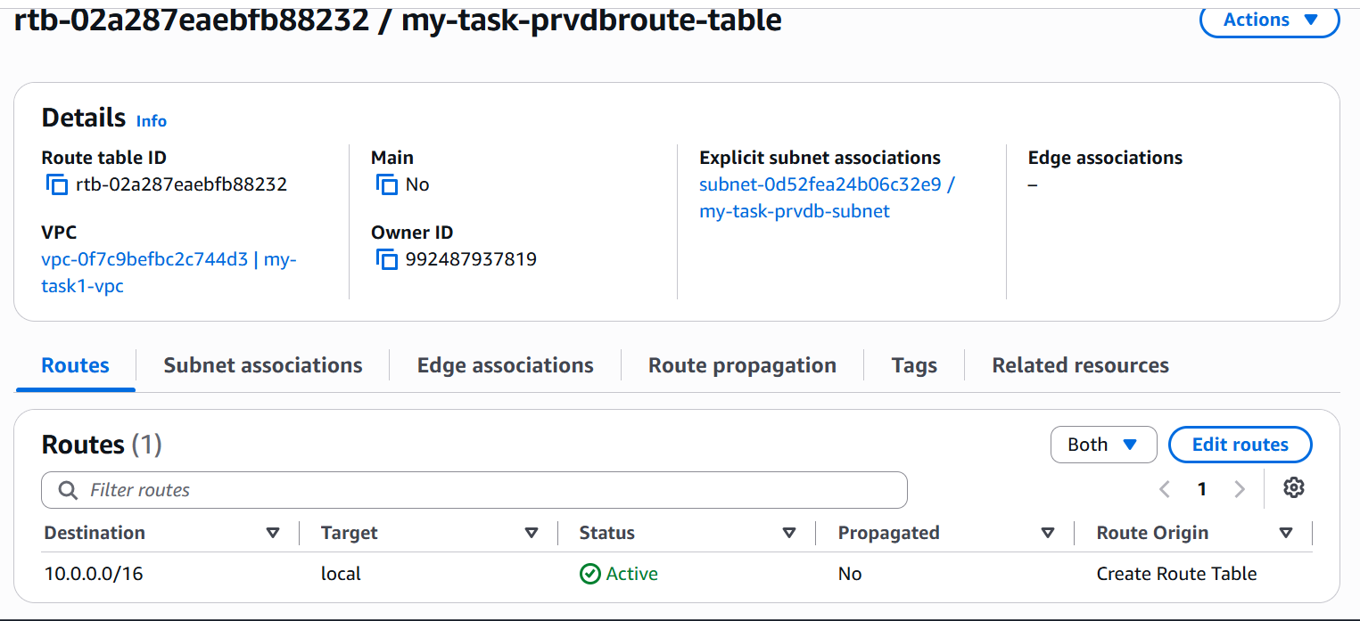

NAT gateway : allocated an elastic IP and created NAT gateway in one of the public subnet

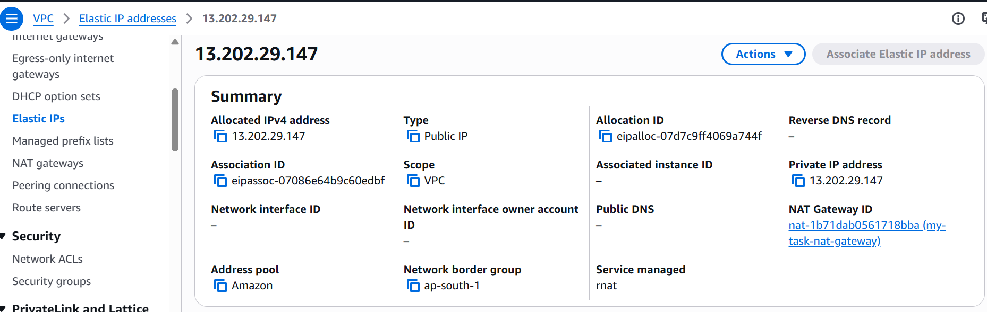

Ensured private resources can access the Internet through the NAT Gateway.
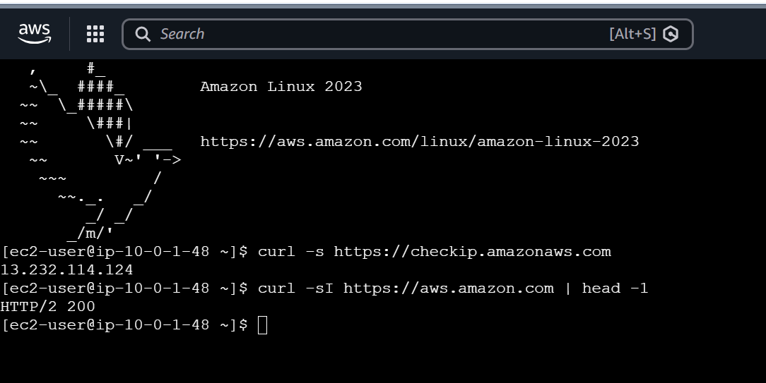

Task2 :
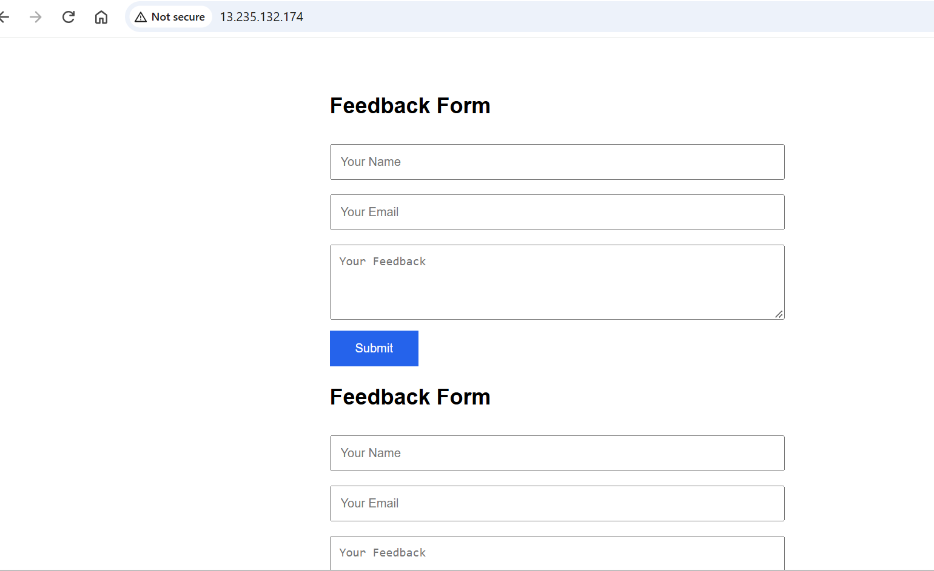

Task 3 - Deploy the Application Tier (Backend API)
Have tried this task scenario in my personal AWS account and shared the result screenshot
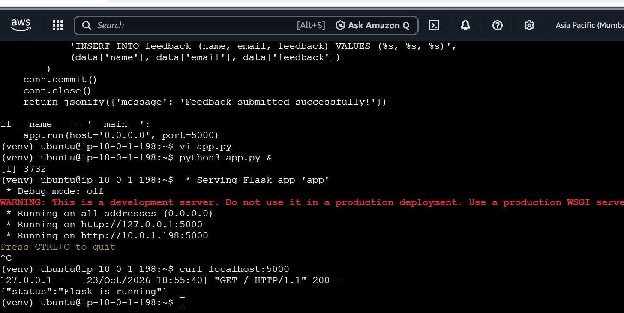

Task 4 - Deploy and Configure the Database Tier

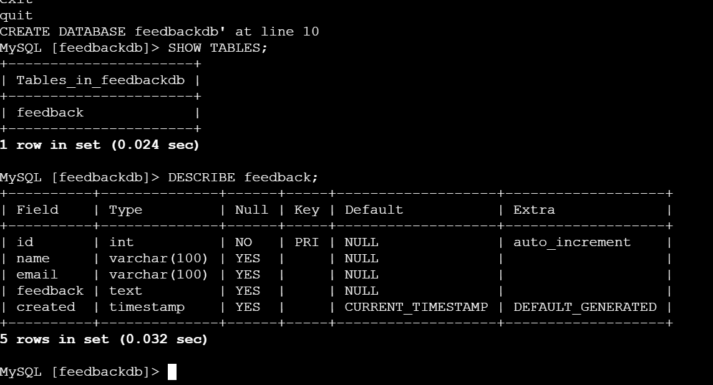
Ubuntu :
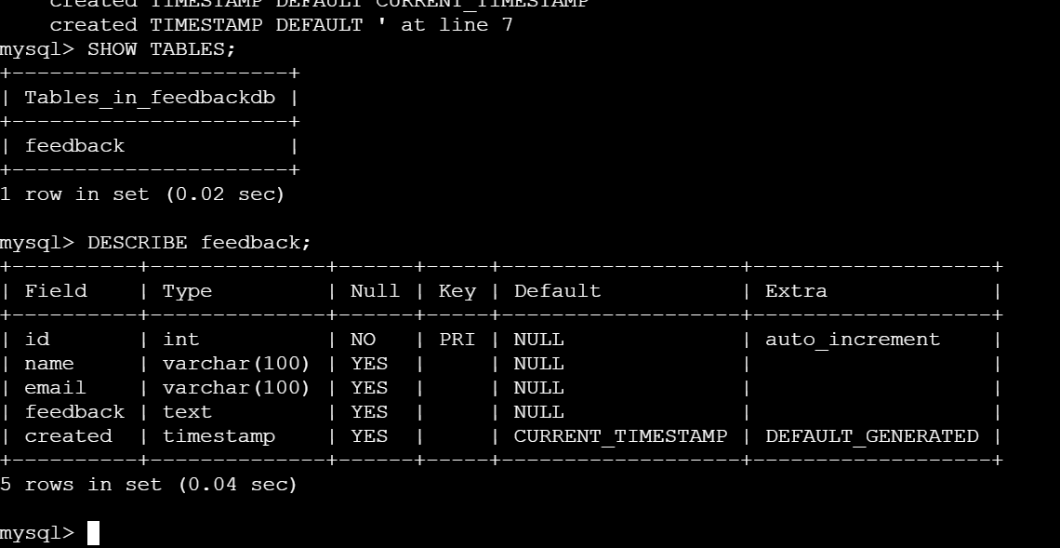

Task 6 : Create an internet-facing Application Load Balancer.

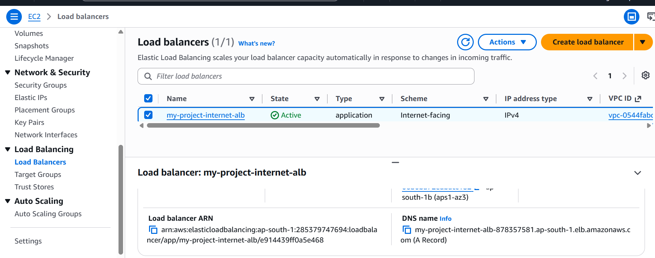

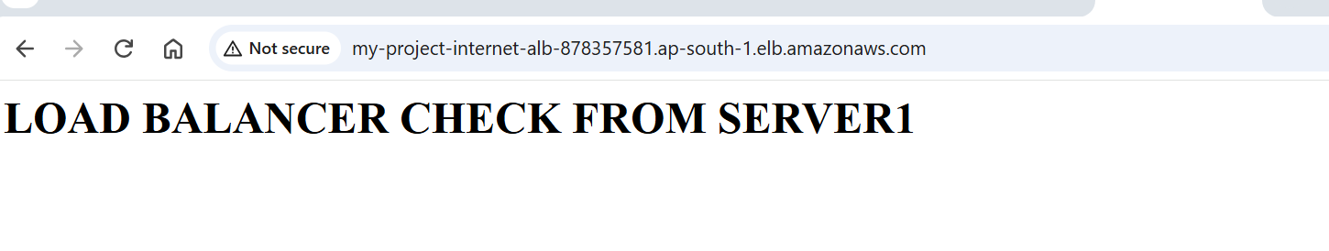
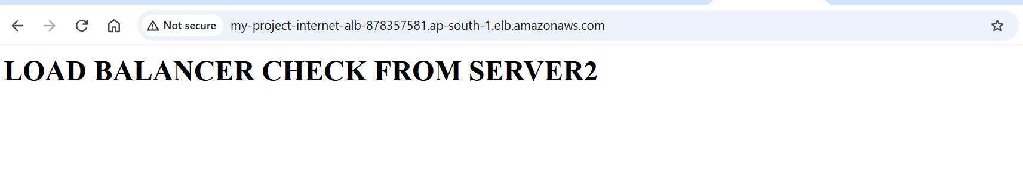
To prove failover, stopped one instance (my-alb-instance1)and the site keeps working from the other(my-alb-instance2) and refreshed the browser page getting the expected result
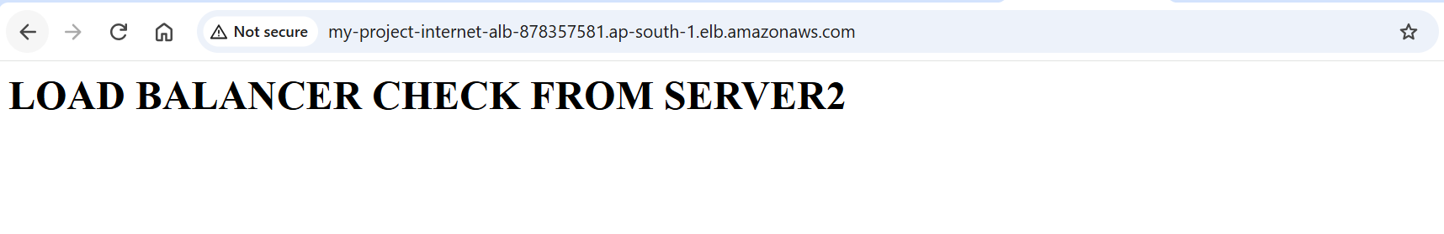
Rest of the task are not completed, not much clear with the task concept
Will work offline and update

